The Best Neighborhood in Toronto to open a Spa

By

Abisola Dolapo Oyesode

In Completion of

Applied Capstone Project

IBM Data Science Professional

Table of Contents

Introduction

Data Collection

Methodology

Result

Discuss

Conclusion

1. Introduction

Toronto, Ontario, was defined as a city in 1834, with a population of 6,197,000 (2020).

Toronto is Ontario’s capital city, Canada’s largest city hall, and ranked as the fourth largest city in North America. It includes the former cities of Toronto, York, Scarborough and Etobicoke, York, and East York.

Toronto is home to many Businesses. One of which is Spa. It is estimated that there were just over 2,300 spa locations in Canada at

March 2006 operated by roughly 2,100 companies.

. Ontario is far and away the largest province accounting for

44% of all Canadian spas. There is still however the need for Spas to be widely located in other parts of Toronto to ease the need to drive long distances to access Spa facilities in a busy, stressed society.

In this project, we are going to look for an optimal location to open a spa. Specifically, this report can provide a reference for stakeholders who are interested in opening a spa in Toronto, Canada. Toronto, city, capital of the province of Ontario, southeastern Canada. It is the most populous city

in Canada, a multicultural city, and the country’s financial and commercial center.

1.1 Business Problem

Toronto is an international center of business, finance, arts, and culture, and is recognized as one of the most multicultural and cosmopolitan cities in the world. In this report, we will focus on all areas in Toronto. There are some Spas in Toronto, we will conclude where are the existing spas. Then we will use a clustering model to find similar areas in Toronto considering demographic data

of each borough and region. The preferred area shall be distant from existing spas. We will use data science tools to fetch the raw data, visualize it then generate a few most promising areas based on the above criteria. In the meanwhile, we will also explain the advantage and traits for the candidates, so that stakeholders can make the final decision based on the analysis.

2.0 Data

After surveying available datasets for Toronto Neighborhoods, I chose to settle with the most three adequate datasets to start my project. As shown below each dataset contains various unique information about Toronto that will help discover the perfect spot to open a spa:

•<https://en.wikipedia.org/w/index.php?title=List_of_postal_codes_of_Canada:_M&direction=prev&oldid=926287641>

•<https://cocl.us/Geospatial_data>

•<https://developer.foursquare.com/docs)>

3.0 Methodology

This report aims to analyze the neighborhoods of Toronto city from different datasets and locate the perfect spot to open a Spa. The following datasets will be utilized in the project:

1) Neighborhoods Dataset:

This dataset contains neighborhood names as well as the geographic coordinates (latitude and longitude). The geographic coordinates will be used for two purposes; visualize Toronto map using Folium and call up boroughs in Toronto.

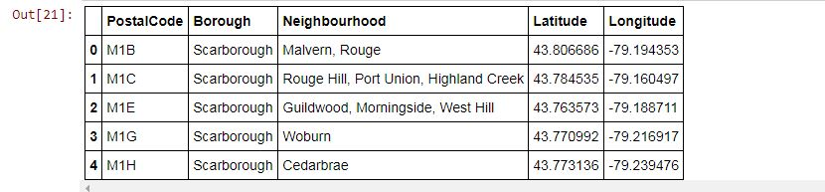

Table Showing Neighborhood and their Longitude and Latitude

2) FourSquare:

Foursquare API is used to collect data to find the most common venues within a specific radius of a given geographic coordinate. Besides, we will find common venues where Spa can be located in each neighborhood.

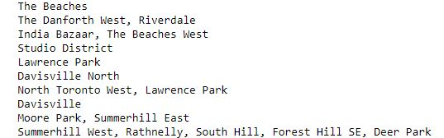

These are common venues in Toronto gotten through Foursquare API

4.0 Results and Discussions

Clusters the Neighborhood

To know which areas, have the least number of Spa or no Spa located therein.

With the data now ready to be clustered, we run k-means to cluster the neighborhoods into three clusters. After observation, we found that Most of the Spa are in cluster 0 which is around

Central Bay Street, Regent Park, The Danforth, West Riverdale. And some in Cluster 1 areas which are in Bercy park, Christie, CN Tower King and Spadina, Railway.There are good opportunities to open a Spa near St James Town, Cabbage town, St Clair west, Avenue Road.

Looking at nearby venues it seems cluster 2 might be a good location as there are few Spas in these areas. The folium map shown below marks the places where Spas are concentrated.

Most of the Spa are in cluster 0 which is around

Central Bay Street, Regent Park, The Danforth, West Riverdale.

And some in Cluster 1 areas which are in Bercy park, Christie, CN Tower, King and Spadina Railway.

There are good opportunities to open a Spa

near St James Town, Cabbage town, St Clair west, Avenue Road.

Looking at nearby venues it seems

It seems cluster 2 might be a good location as there are few Spas in these areas.

Therefore, this project recommends the entrepreneur to open an authentic Spa in these locations.

